|  |  |  |  |
| --- | --- | --- | --- |
| **Campus** | **NPI** |  | Please Tick (✓) for  **Re-do Assignment** |
| **APU Foundation & Degree**  **Programmes** | |  |

**Coursework Submission and Feedback Form**

|  |  |  |  |  |  |
| --- | --- | --- | --- | --- | --- |
| **Name** | **SAJAG SHRESTHA** | | | | **Name of Group Members (If Applicable)** |
| **Student No.** | **NPI000172** | | **Intake:** | **NPI1F2202IT** |  |
| **Module Code & Title** | **CT042-3-1-IDB** | | | |  |
| **Assignment Title** | **UPA LIBRARY MANAGEMENT SYSTEM** | | | |  |
| **Name of Lecturer** | **ER. ISHA BARAL** | | | |  |
| **Date Due** | **23 JUNE 2022** | **Student E-Mail:** [**sajagcrestha@gmail.com**](mailto:sajagcrestha@gmail.com) | | |  |

*I have read and understood the regulations on Plagiarism and Academic Dishonesty and declare that the work submitted does not breach those regulations.* **Signed: ________________________________**

**You must hand in to the designated APU Administrator – ensure that you receive your receipt**.

|  |  |  |  |  |  |  |  |
| --- | --- | --- | --- | --- | --- | --- | --- |
| **Received By** |  | **Signature** |  | **Date** |  | **Time** |  |

|  |  |  |  |  |  |  |  |  |  |  |  |
| --- | --- | --- | --- | --- | --- | --- | --- | --- | --- | --- | --- |
| **Criteria** | | | **Weighting** | | **Fail** | **Marginal**  **Fail** | **Pass** | | **Credit** | | **Distinction** |
|  | | |  | |  |  |  | |  | |  |
| **Additional Comments:** (These may be listed below or attached) | | | | | | | | | | | |
|  | | | | | | | | | | | |
| **Provisional Assessment Result: Grade Date Lecturer’s Initial**    Taking account of above factors, the overall provisional assessment of your work is: | | | | | | | | | | | |
|  | | | | | | | | | | | |
| **Distinction** | | **Credit** | | | | **Pass** | | | | | |
| **A+: 80-100%** | **A: 75-79%** | **B+: 70-74%** | | **B: 65-69%** | | **C+: 60-64%** | | **C: 55-59%** | | **C-: 50-54%** | |
| **Marginal Fail** | | **Fail** | | | | | | | | | |
| **D: 40-49%** | | **F+: 30-39%** | | | | **F: 20-29%** | | | **F-: 0-19%** | | |

*The comments and assessment result are subject to both internal and external moderation at the appropriate Examination Board.*

*Consequently, they may not reflect your final grade. You may not appeal against these result on ground of Academic Judgement.*

# 

# Table of Contents:

SQL-Data Definition Language (DDL) 1

Database Creation: 1

Create Table: 1

Insert into Table: 5

SQL-Data Manipulation Language (DML) 11

Queries: 11

a. 1st Query: 11

b. 2nd Query: 11

c. 3rd Query: 12

d. 4th Query: 12

e. 5th Query: 13

f. 6th Query: 13

g. 7th Query: 14

h. 8th Query: 14

i. 9th Query: 15

j. 10th Query: 15

k. 11th Query: 16

l. 12th Query: 17

References 18

# SQL-Data Definition Language (DDL)

There are all sorts of syntaxes for the creation of database, creating of database, creation of tables, inserting values into the table, update the values in the table, delete data from the table. Following are the description for the syntaxes simultaneously.

## Database Creation:

In SQL, first of all creation of database is necessary. We cannot create tables without database creation. For creating database following syntax is used:



### Create Table:

After creating a database, you can create a table and insert data/values in the table as various data types all inside the previously created database. Following syntax is required to create a table including Primary key and Foreign Key.

* **Publisher Table:**

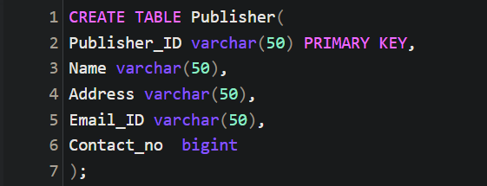

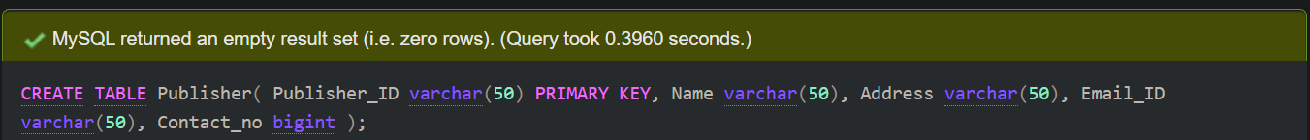

* **Author Table:**

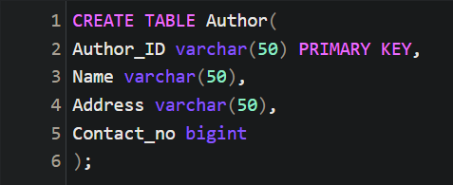

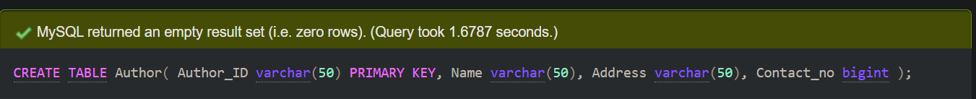

* **Book Table:**

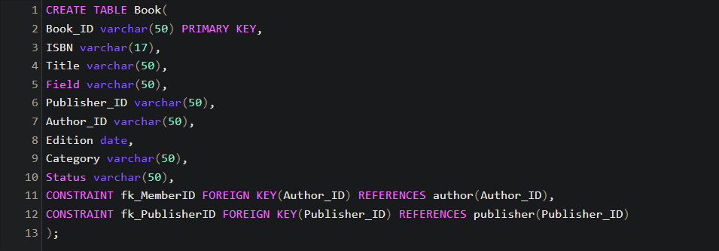

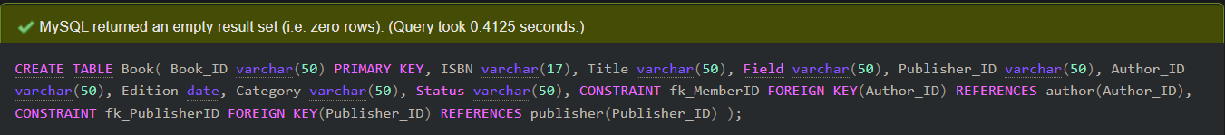

* **Classification Table:**

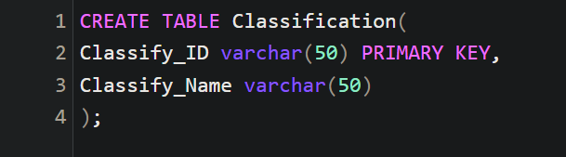

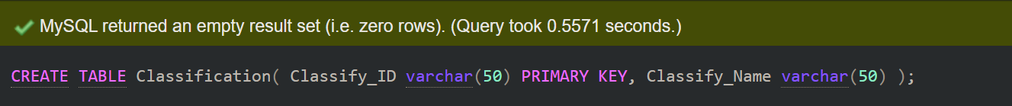

* **Member Table:**

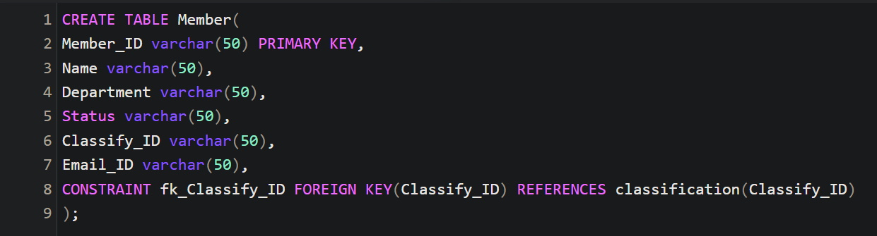

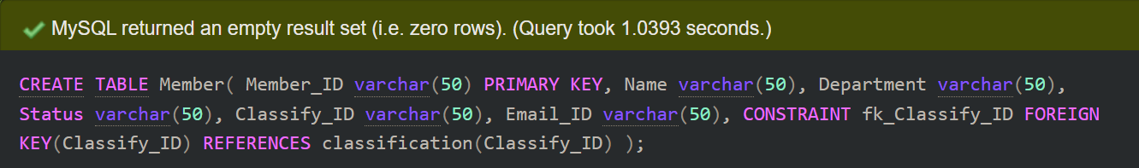

* **Transaction Table:**

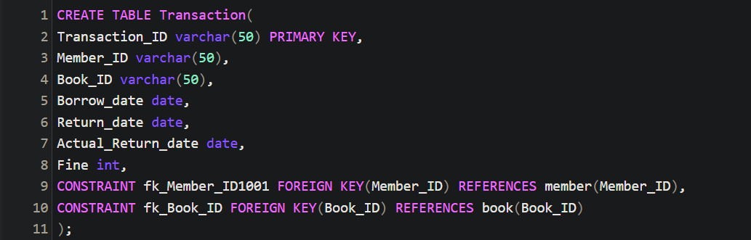

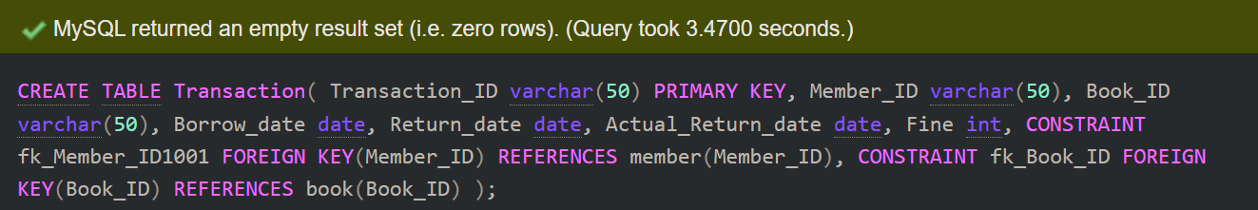

* **Reservation Table:**

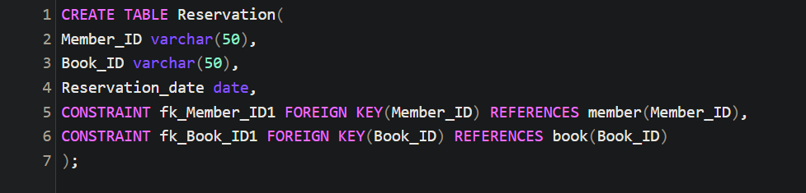

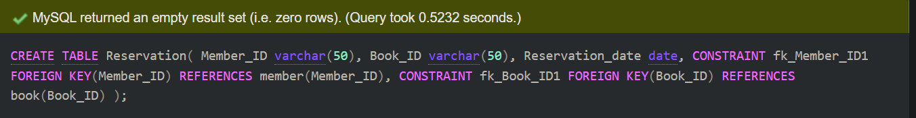

### Insert into Table:

You are required to insert the values into the table after creating the table.

* **Publisher Table:**

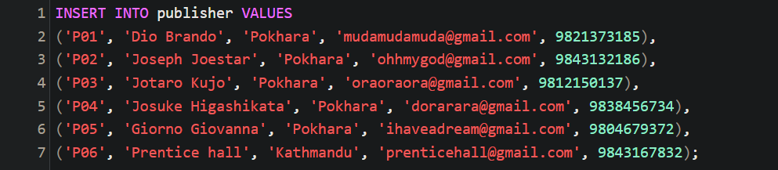

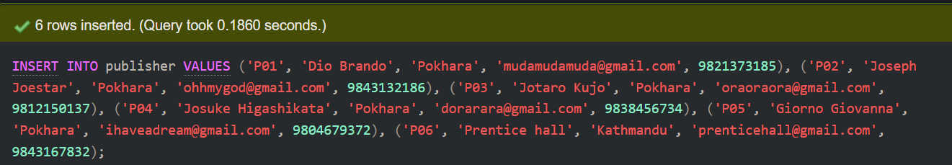

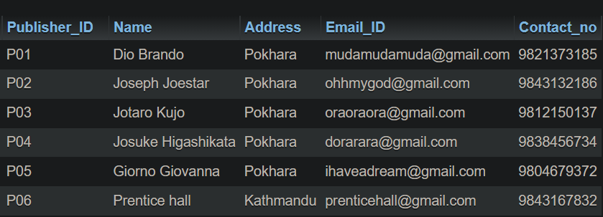

* **Author Table:**

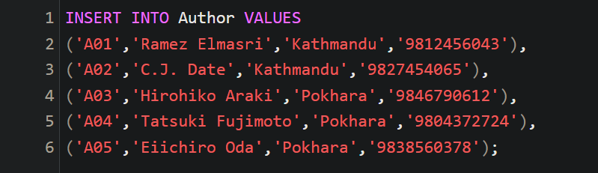

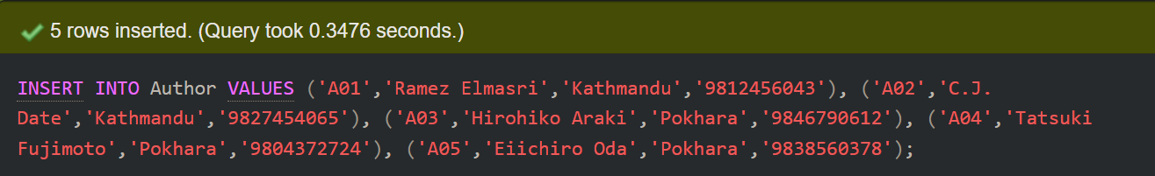

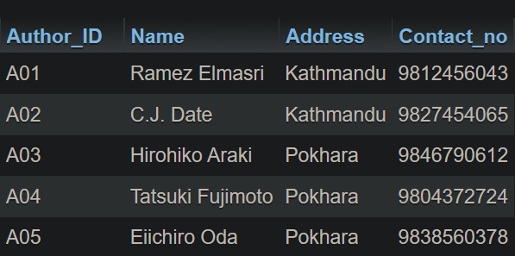

* **Book Table:**

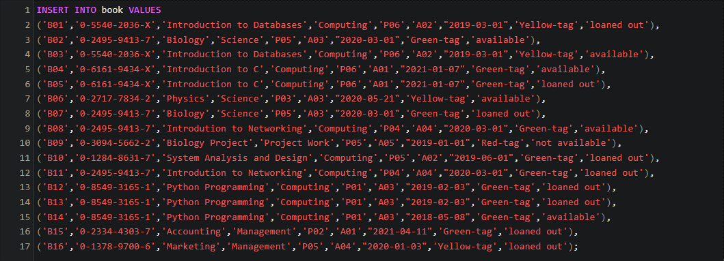

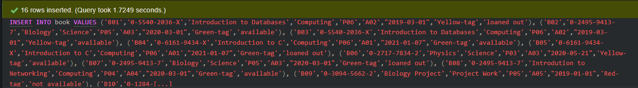

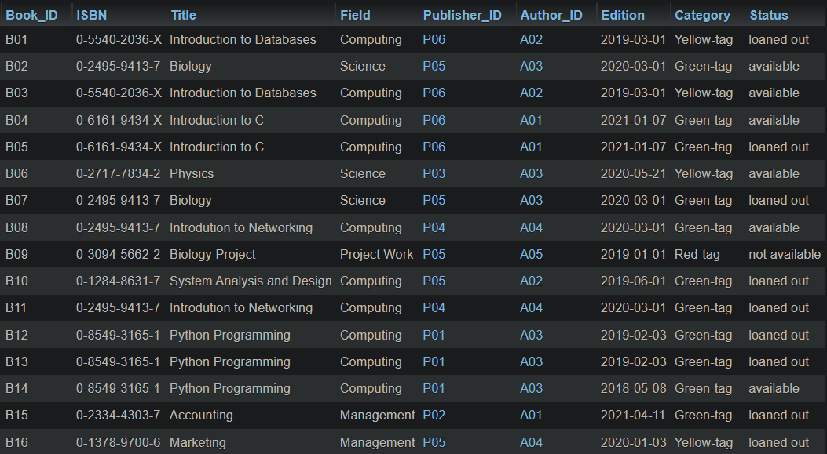

* **Classification Value:**

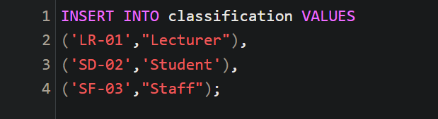

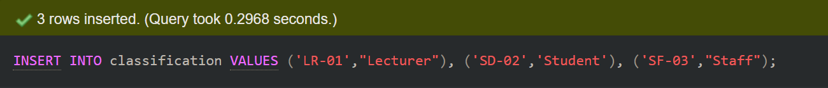

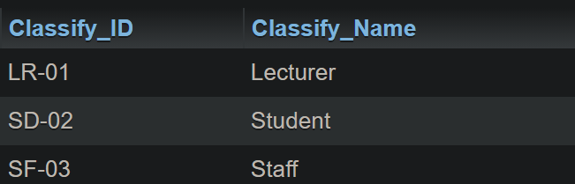

* **Member Value:**

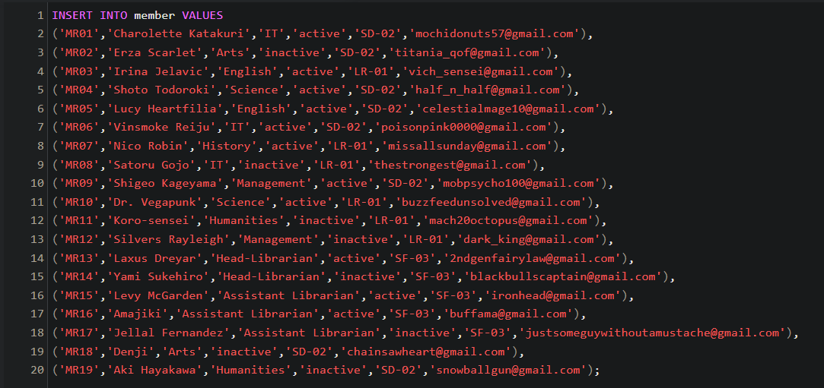

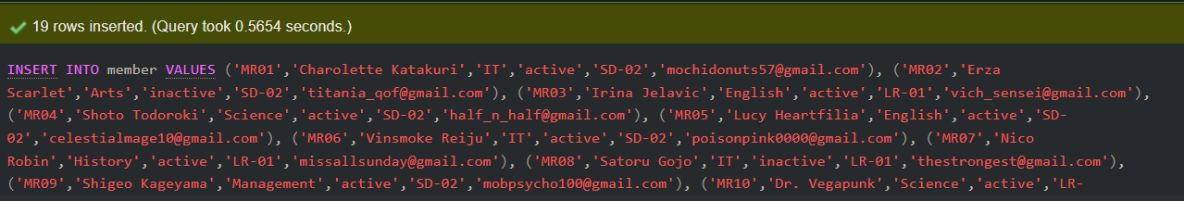

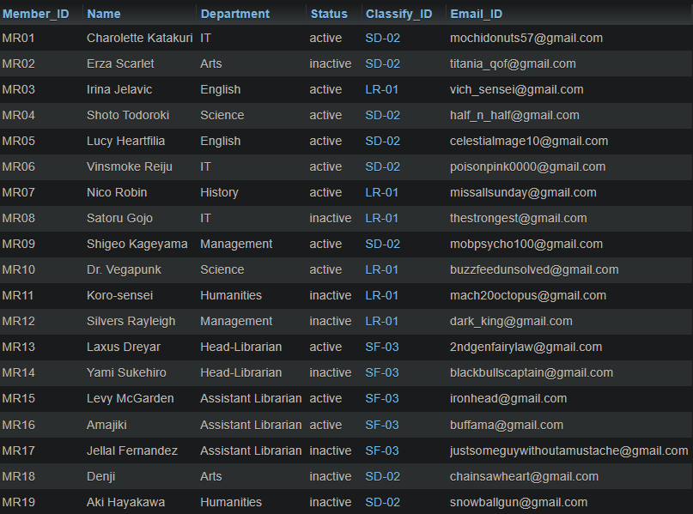

* **Transaction Value:**

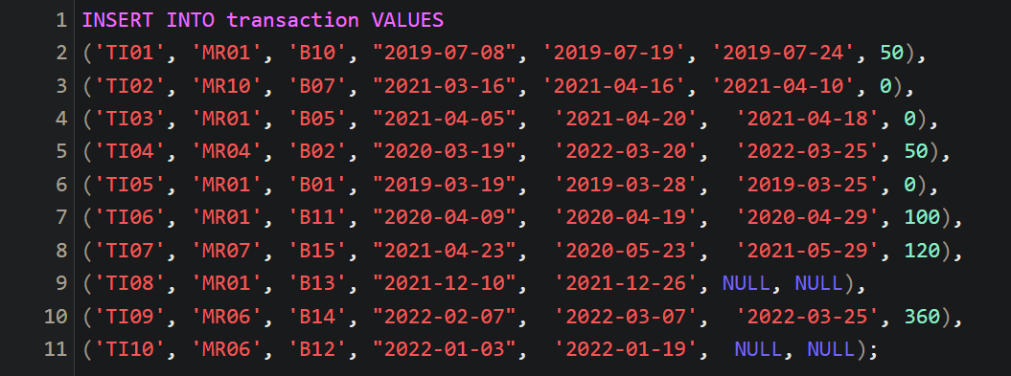

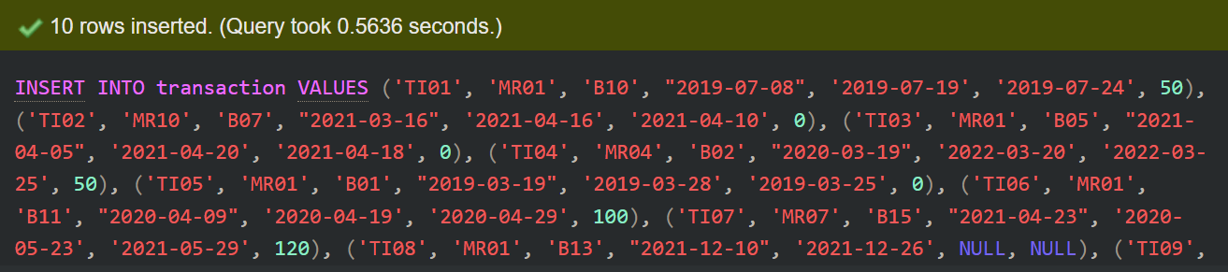

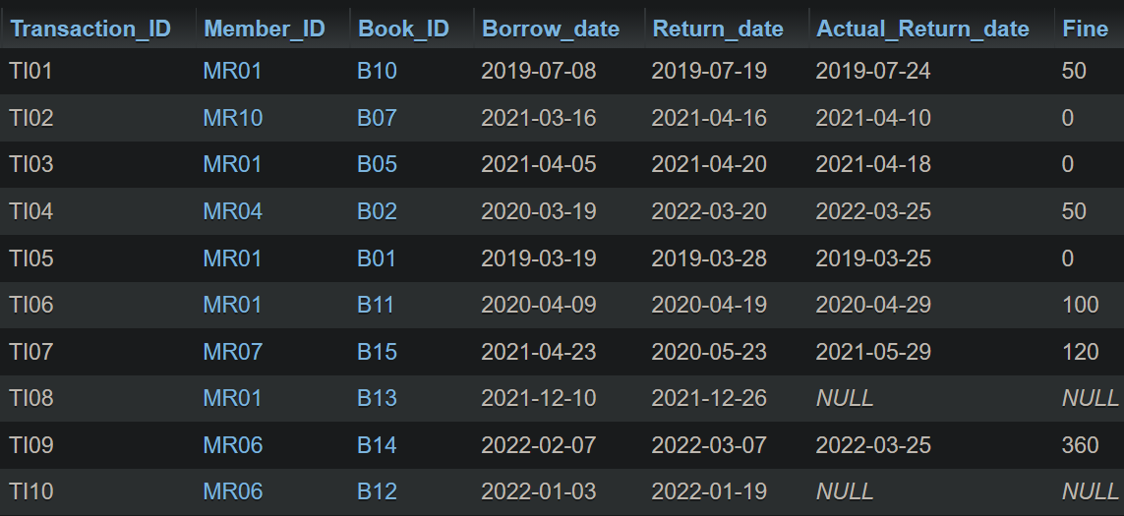

* **Reservation Value:**

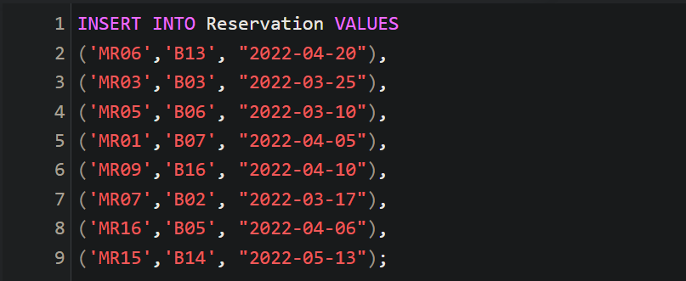

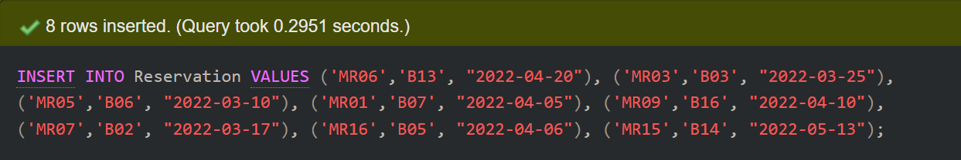

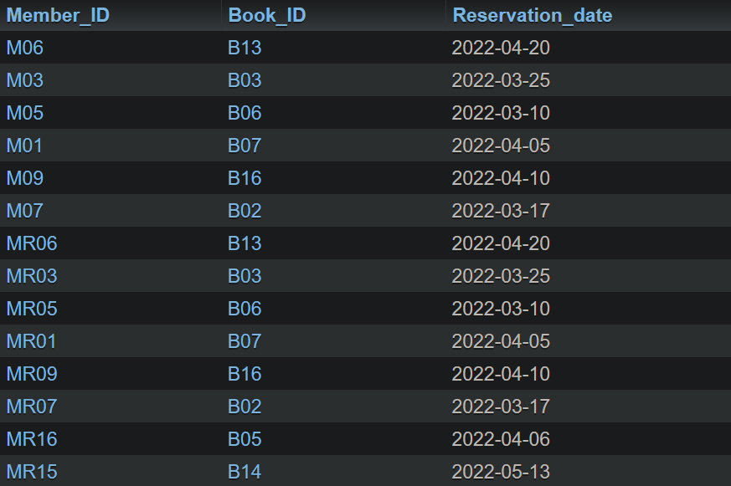

# SQL-Data Manipulation Language (DML)

## Queries:

### 1st Query:

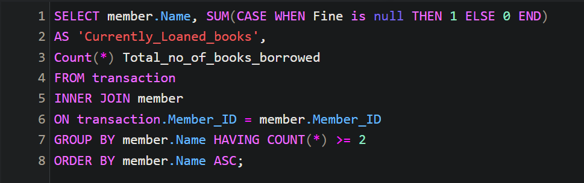

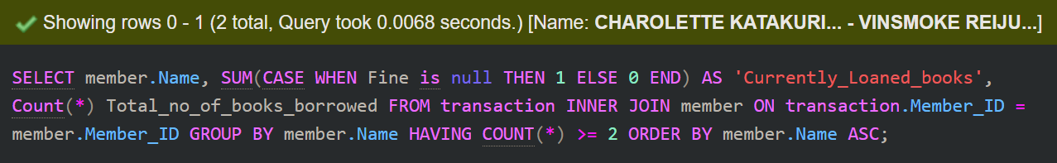

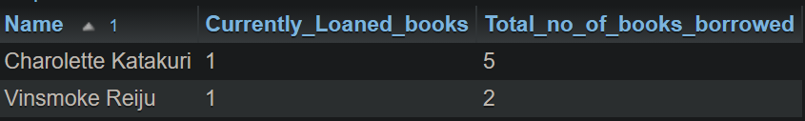

### 2nd Query:

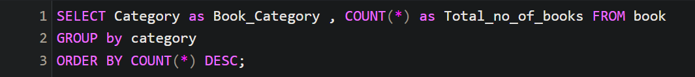

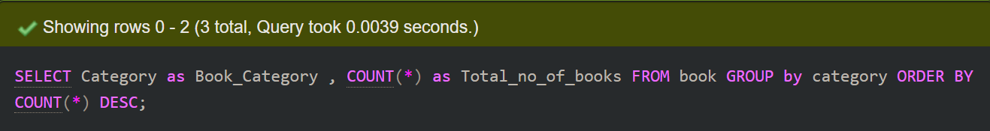

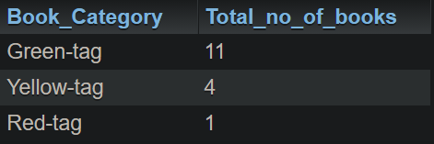

### 3rd Query:

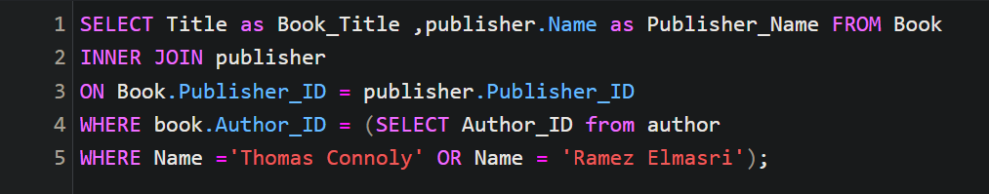

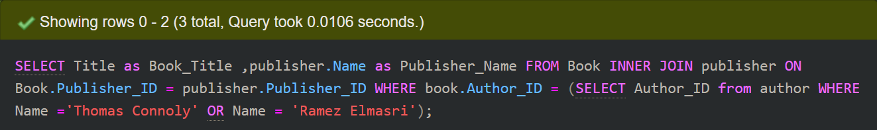

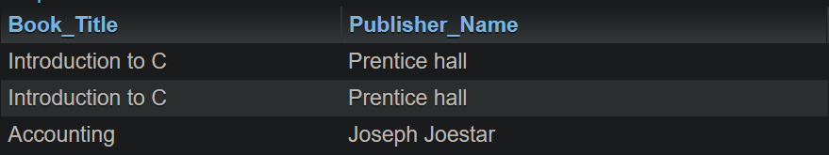

### 4th Query:

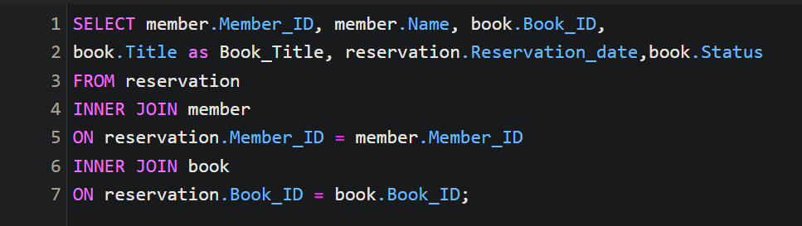

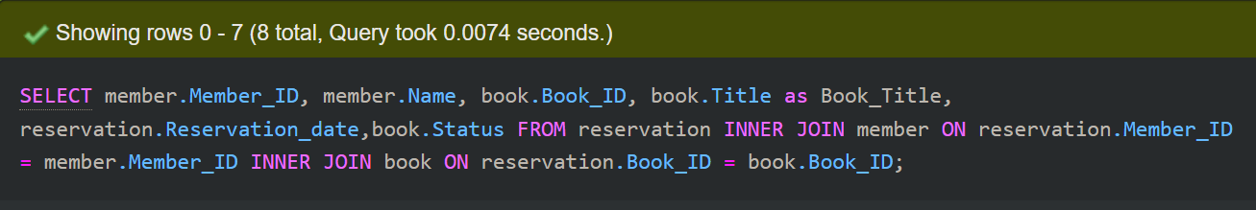

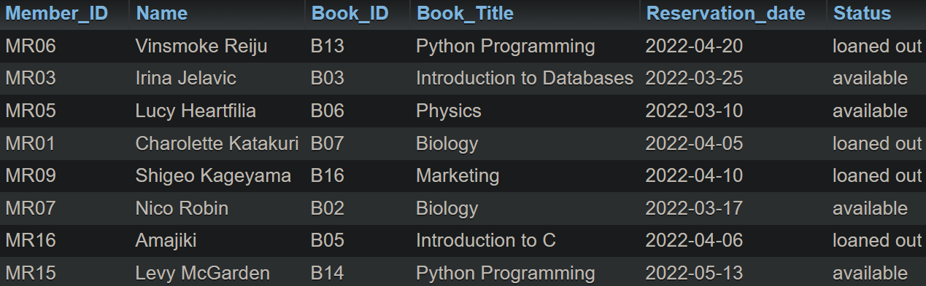

### 5th Query:

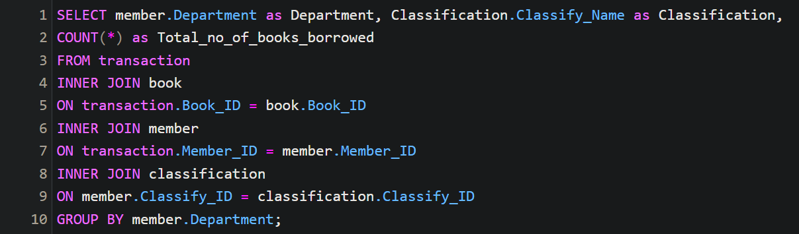

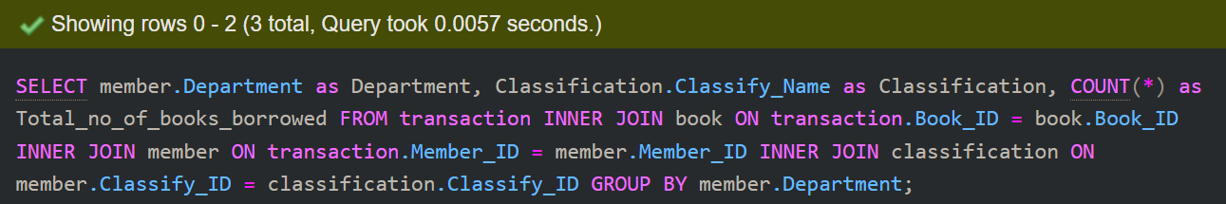

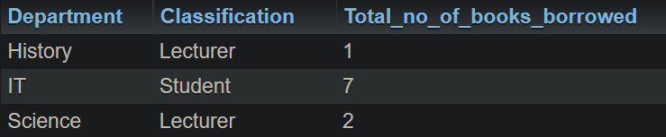

### 6th Query:

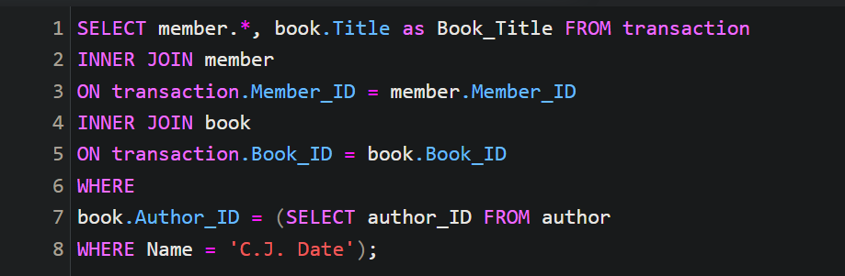

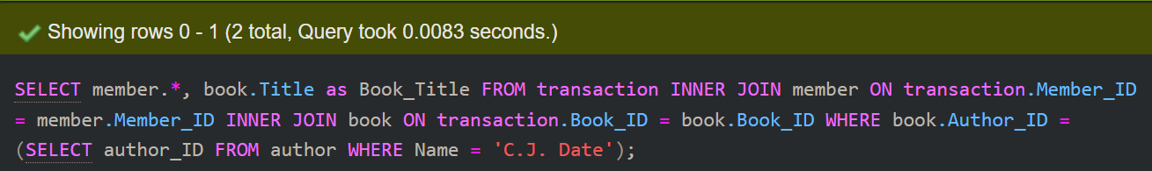

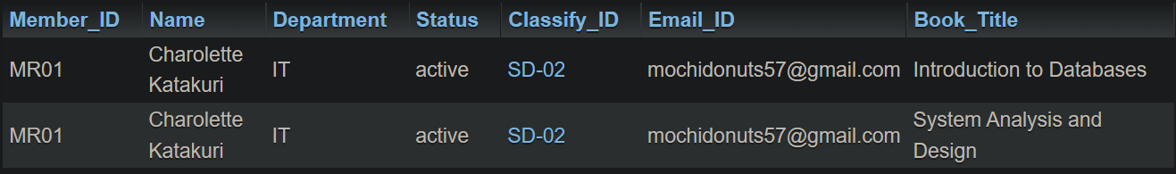

### 7th Query:

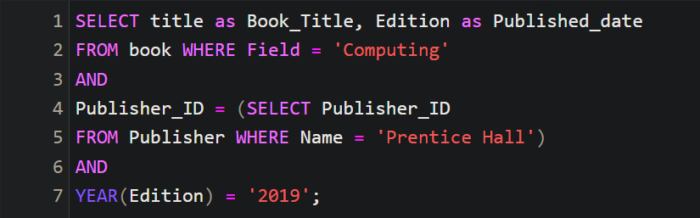

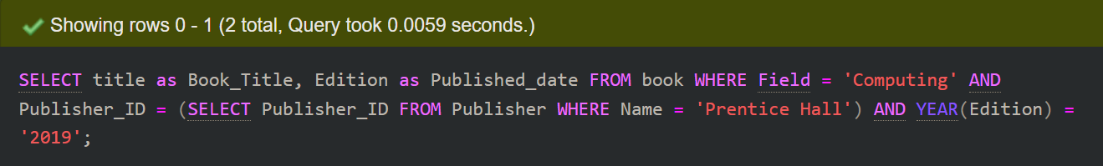

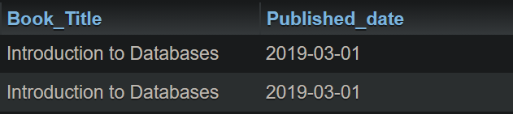

### 8th Query:

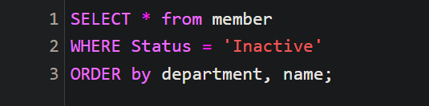

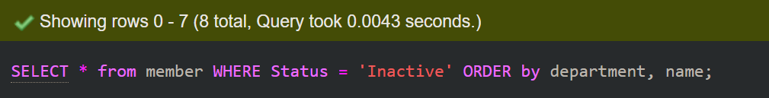

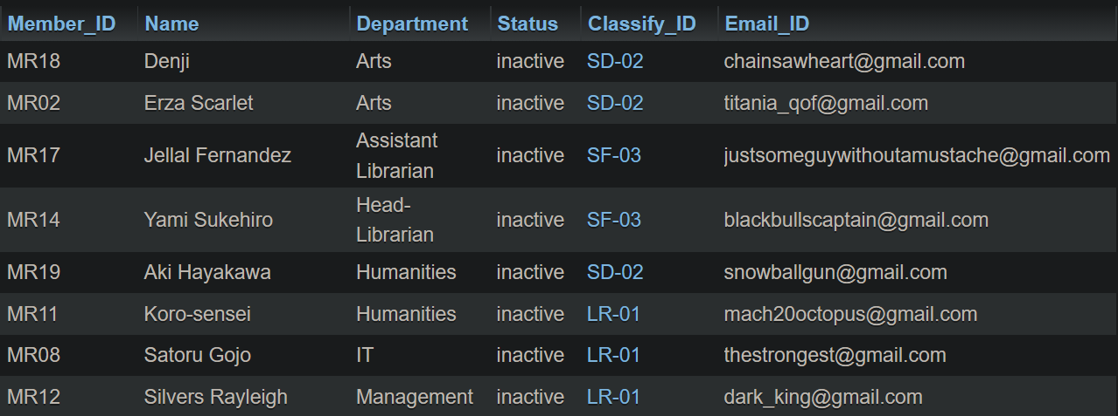

### 9th Query:

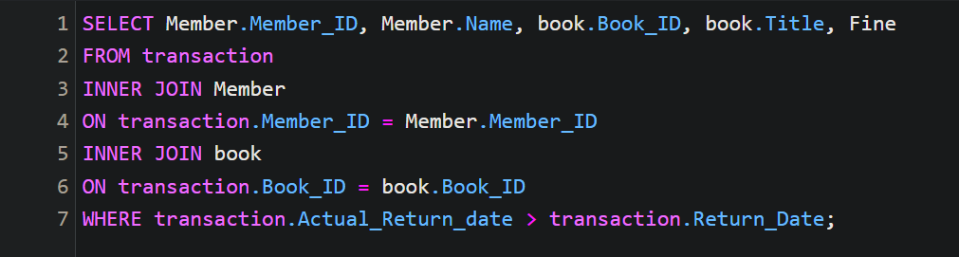

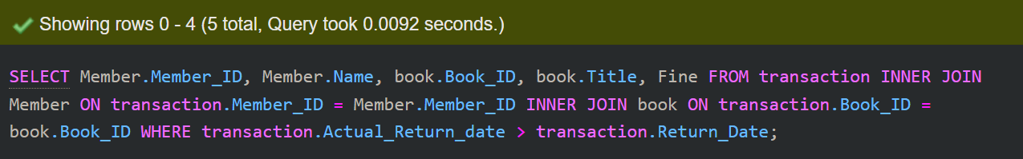

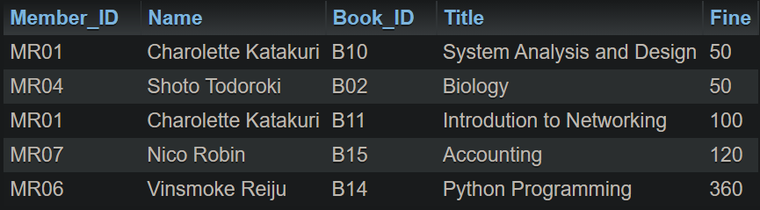

### 10th Query:

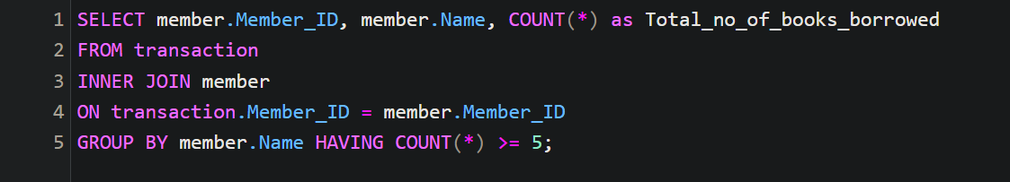

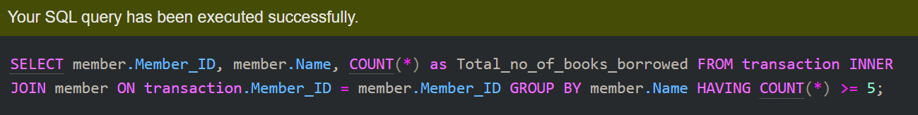

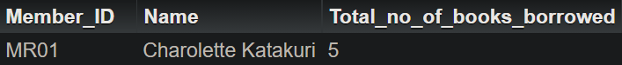

### 11th Query:

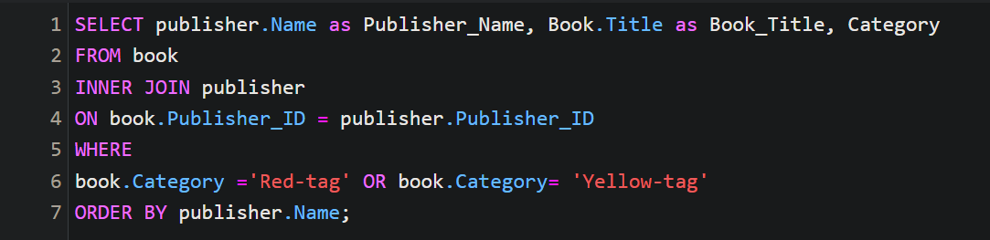

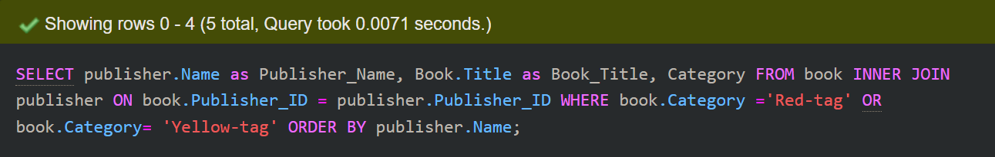

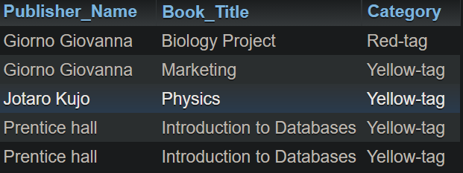

### 12th Query:

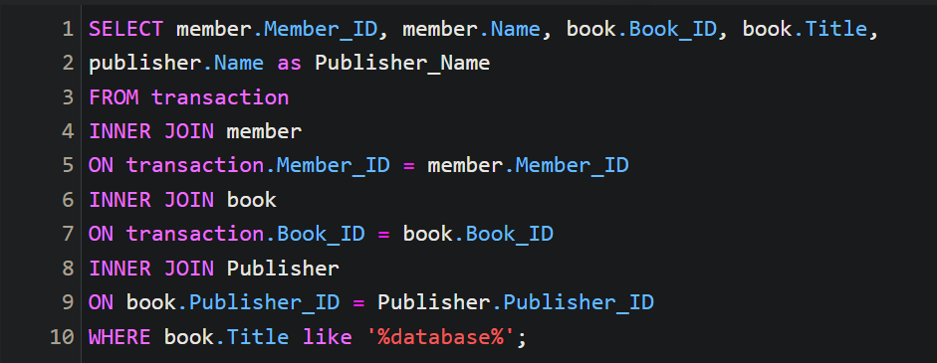

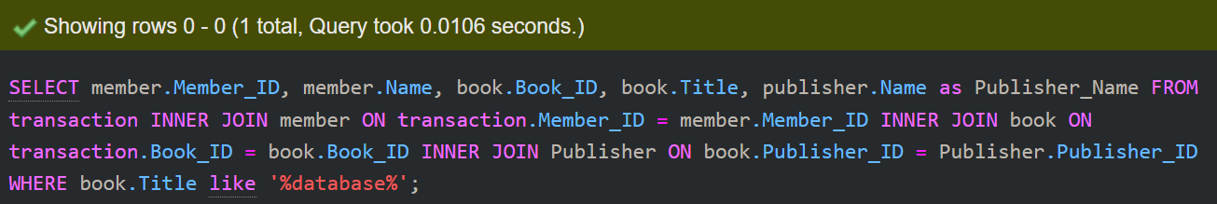



# References

Hector Garcia-Molina, Jeffrey D. Ullman, Jennifer Widom: 2009,

Pearson Prentice Hall Database System the Complete Book. Pearson Prentice Hall: Available at: https://people.inf.elte.hu/miiqaai/elektroModulatorDva.pdf

Ben Brumm, Jun 23, 2021, Database Design for a Library Management System [Video]

https://youtu.be/yldrIdoXiYk?t=26

Paul Beynon-Davies, Third Edition, Database Systems.

Raghu Ramakrishanan & Johannes Gehrke. Database Management System, Second Edition.

Sikkim Manipal University, Database Management System, Edition 2009

Toby Teorey, Sam Lightstone and Tom Nadeau, Database Modeling & Design, Fourth Edition

M.V.Kamal, Department of Computer Science & Engineering

Malla Reddy College of Engineering & Technology. [pdf]

https://mrcet.com/downloads/digital_notes/ECE/III%20Year/DATABASE%20MANAGEMENT%20SYSTEMS.pdf

SQL Tutorial,

https://www.w3schools.com/sql/

Deborah Morley, Charles S. Parker, 6/10/2015[pdf]:

https://www.oakton.edu/user/2/rjtaylor/CIS101/Text/PowerPointPresentations/morley15e__ppt_ch14%20REV.pdf

Learn S.Q.L

https://www.tutorialspoint.com/sql/index.html